If you have a dog, you really must scoop the poop! Dog waste is an environmental pollutant. According to estimates by the EPA, 2-3 days’ worth of droppings from a population of about 100 dogs can contribute enough bacteria to temporarily close a pond or lake and all watershed areas within 20 miles to swimming and fishing. #WeAllLiveDownstream #Scoopthepoop #CleanStormwater

If you have a dog, you really must scoop the poop! Pet waste can harm your health. Many don’t realize it, but dog waste often carries parasites and bacteria that can be transmitted directly to humans and make them sick. #WeAllLiveDownstream #Scoopthepoop #CleanStormwater

If you have a dog, you really must scoop the poop! Contaminated waste can make dogs sick. When pets become sick, contagions are typically passed through their deposits and into the yard. The longer infected dog waste stays on the ground, the greater a contamination becomes. When this waste is not picked up, pets have a high risk of catching infections over and over again. #WeAllLiveDownstream #Scoopthepoop #CleanStormwater

If you have a dog, you really must scoop the poop! Pet waste doesn’t just disappear. Bacteria, worms and other parasites thrive in unattended waste, eventually breaking down into the soil and washing into the water supply. Roundworm, for example, is one of the most common parasites found in dog waste, and it can remain infectious in contaminated soil and water for years. #WeAllLiveDownstream #Scoopthepoop #CleanStormwater

Scoop the poop! Rodents love pet waste. Dog poop can be a common food source for rats and other rodents in developed areas. An unwanted neighbor in any community, the presence of rodents can decrease the property values of all nearby homes and presents a host of additional health concerns to residents themselves. #WeAllLiveDownstream #Scoopthepoop #CleanStormwater

Scoop the poop! Dog waste is far from fertilizer. Unlike herbivores, a dog’s diet is made up of mostly animal products, making their waste unsuitable for soil enrichment. Leaving pet waste on the ground or concentrating it in one specific area of the yard can have a detrimental effect on soil quality. #WeAllLiveDownstream #Scoopthepoop #CleanStormwater

If you have a dog, please scoop the poop! Mowing over doggie deposits does not solve the problem. Running doggie deposits over with a lawn mower may seem like the perfect doody disappearing act, but just because you can’t see the waste anymore doesn’t mean it’s not there. Pet waste contains approximately twenty-four million coliform per ONE gram! #WeAllLiveDownstream #Scoopthepoop #CleanStormwater

If you have a dog, you scoop the poop! Children are at risk from exposure to pet waste. Children at play may not wash their hands and most do not realize the potential hazards of coming into contact with waste that has been left on the ground. The bacteria and parasites found in dog droppings are most commonly passed to humans by touch. #WeAllLiveDownstream #Scoopthepoop #CleanStormwater

Pet waste is a threat to human and environmental health because it contains harmful bacteria and pathogens, many of which can cause serious diseases in humans, including serious gastrointestinal infections (E. coli in pet waste can cause kidney damage and even death.), as well as infections to the ear, eye, and throat. Pet waste also contains many other nutrient pollutants, which contribute to excessive algae growth in a water body, upsetting the delicate balance of the natural habitat.

There are an estimated 74.8 million dogs owned in the United States, that produce 72.5 billion pounds of dog waste every year! Just one gram of pet waste contains an average of 23 million fecal coliform bacteria. Many of these bacteria can cause serious gastrointestinal infections, as well as infections to the ear, eye, and throat in humans. As pet waste decomposes, it demands a high level of oxygen from water. This demand can suffocate fish and plant life by reducing the amount of oxygen available to them.

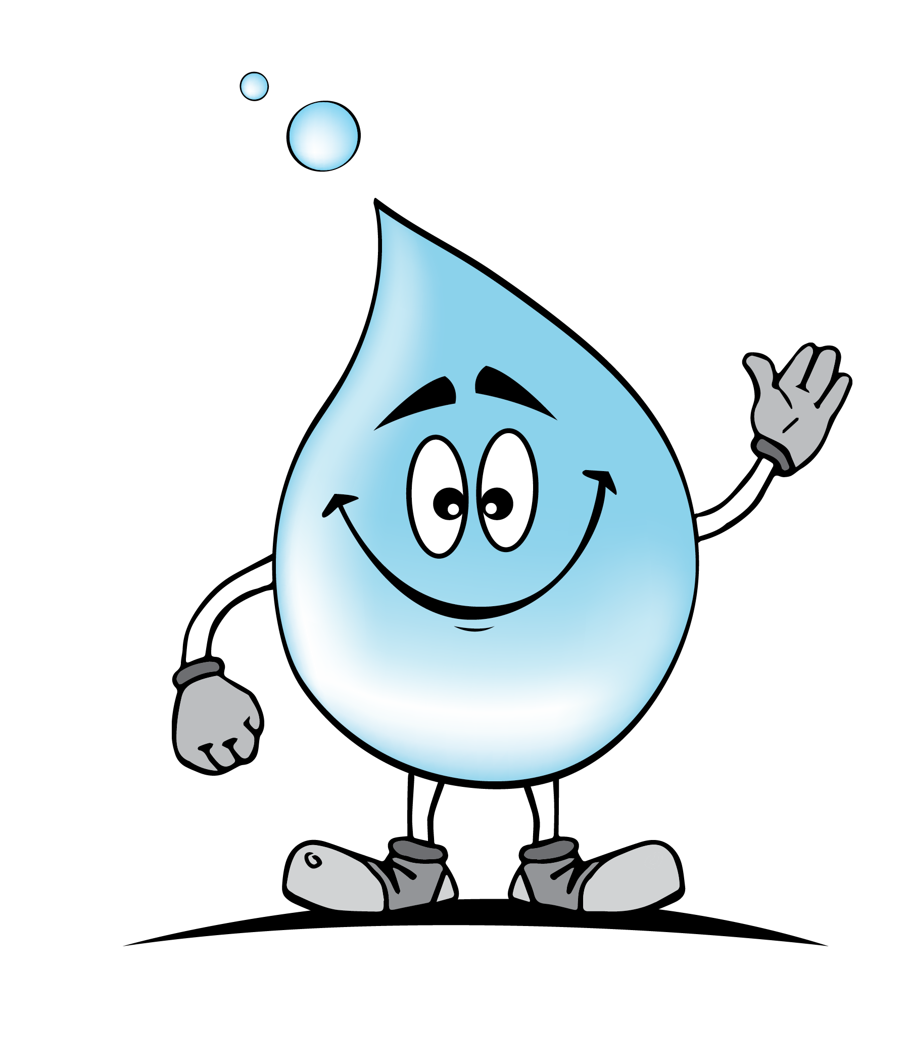
https://www.instagram.com/p/BwHW0Nan3Rh/?utm_source=ig_web_button_share_sheet

https://www.instagram.com/p/By5n3XzFuYU/

https://braintreema.gov/DocumentCenter/View/4303/Braintree-Pet-Waste-Brochure-rev-3?bidId=

Puget Sound rocks it! Dog Doogity- bag it up!

PSA for ScoopPoop.org (Blackstreet - No Diggity spoof) ft Martin Luther
https://www.youtube.com/watch?time_continue=91&v=jDh12w-jcfs

