SALT LAKE COUNTY
STORMWATER COALITION
2018-19 ANNUAL REPORT

For the period July 1, 2018- June 30, 2019

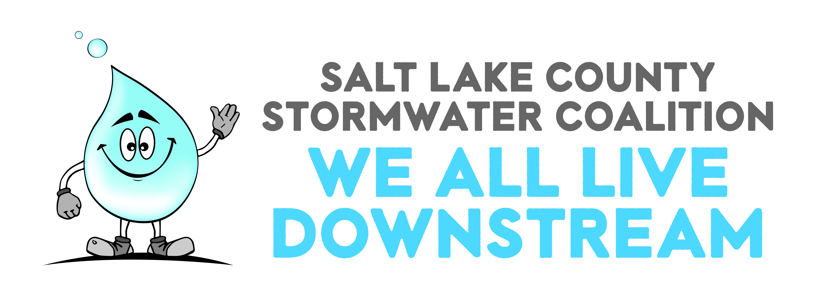

Executive Summary

The 2018-19 Salt Lake County Stormwater Coalition Annual Report serves to convey the required information and detail the status of compliance regarding permit conditions, as well as provide a review of Coalition programs, activities and function within the Jordan Valley MS4 UPDES permits toward achieving measurable goals for Minimum Control Measures 1) public education and outreach, and 2) public participation and involvement. This report covers the period of July 1, 2018 to June 30, 2019.

Background

Salt Lake County Public Works Engineering is the Administrator and Coordinator of most of the UPDES Countywide MS4 permit education, outreach, participation and involvement (PIE) requirements and has been since 1995. The Stormwater Coalition is the main arm of these programs under County management and is crucial for compliance with the MS4 permits. The Stormwater Coalition is comprised of 21 stakeholders, including: SL County, Bluffdale, Cottonwood Heights, Draper, Herriman, Holladay, Midvale, Millcreek, Murray, Riverton, Salt Lake City, Sandy, South Jordan, South Salt Lake, Taylorsville, West Jordan, West Valley City, Utah Department of Transportation, Salt Lake County Health Department, Greater Salt Lake Municipal Services District, and the Veterans Administration- Salt Lake City Regional Department of Affairs and Health Care System.

Stormwater Coalition Approach

Salt Lake County Public Works Engineering Division administers the Stormwater Coalition and serves as a backbone organization for coalition member municipalities and organizations. On behalf of the Coalition, Salt Lake County has engaged Social Marketing Consultants (SMC), a public relations and consulting firm, to help meet requirements of the Jordan Valley MS4 UPDES permits and to continue and expand successful implementation and further development of public information, education, participation and involvement.

The primary goals of the Stormwater Coalition are to increase awareness regarding the significance of nonpoint source stormwater pollution and to affect positive behavior changes among specific audiences, emphasizing their role in keeping stormwater pollutants such as sediments, oil and greases, surfactants, fertilizers, pet waste, industry byproducts and other contaminants from entering the storm drain system which discharges to water bodies throughout Salt Lake County and the State of Utah.

Stormwater Coalition members contribute to and engage in implementation of evidence-based methods (such as Best Management Practices), outreach practices, shared financial resources, problem solving ideas, and knowledge of solutions to address local behaviors that impact stormwater with a singular purpose, working to spread the key message that “We all live downstream”. The Stormwater Coalition began applying a model known as Collective Impact in the spring of 2019. Collective Impact is an approach to partnership work that requires stakeholders to adopt specific tenants in their work together in order to accomplish a common purpose (https://ssir.org/articles/entry/collective_impact). The Coalition expects to expand its capacity in the achievement of quantifiable results and will report at regular intervals on the clear, specific, measurable indicators of behavior change efforts, beginning with its social media campaigns implemented over the reporting period (baseline), and with its mainstream media campaigns. Baseline for TV ads was established in May and September 2018, and baseline for bus banners, digital billboards and theater trailers will be captured as delivered in September–October 2019.

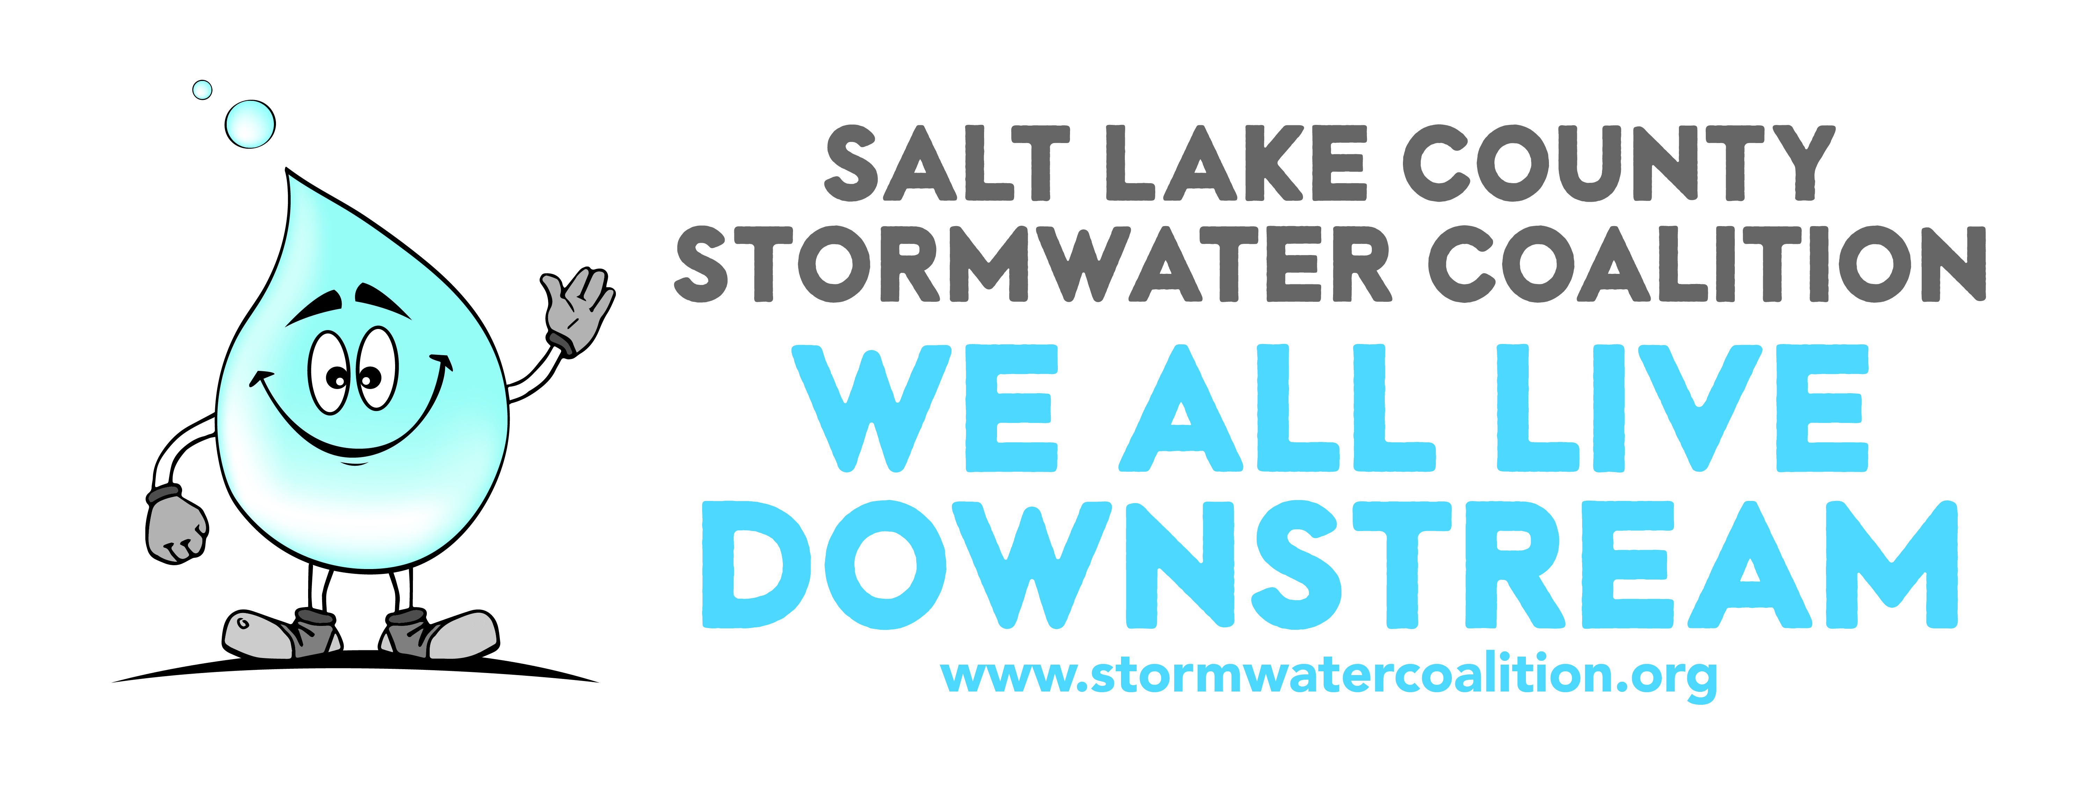
As a hallmark of its branding, the Stormwater Coalition utilizes a spokes-character, “Droplet” along with the slogan, “We All Live Downstream” to maintain SLCo Stormwater Coalition recognition and identity over the reporting period and throughout its outreach, education, engagement and messaging efforts, which included:

- Implementation non-technical information programs to educate the general public including: residents, homeowners, and businesses about aspects of stormwater pollution and its abatement and control;
- Implementation of technical education program for developers, planners, architects, engineers, elected officials, and community leaders, etc. on the water quality aspects of stormwater runoff and methods for improvement;
- Implementation of training programs for public sector personnel (municipal operations and public works departments) for the protection of stormwater quality;
- Engagement and education of teachers and 4th and 10th grade students (Utah Core includes water quality elements for these grades), including the delivery of the 13th Annual Water Quality Fair at Hogle Zoo for 4th grade students;
- Outreach and engagement through social media platforms, including the Stormwater Coalition website, Facebook, Twitter, and Instagram;
- Distribution of guidance documents and other items that promote best stormwater management practices for residents and businesses;
- Delivery of Presentations and/or Activities to Various Community and Civic Events;
- Delivery of Public Service Ads/TV Commercials (Sept. 2018)
- Production of Public Service Ads/TV Commercials and appearances on local TV and radio programming and public events (delivery in Oct. 2019);
- Production of Public Service Ads shown in conjunction with movie theater previews (delivery in Oct. 2019);
- Production of static Public Service Messaging on billboards (including digital billboards) and transit vehicles (busses) (delivery in Sept-Oct. 2019);
- Engagement in monthly stormwater coalition meetings;
- Implementation and of data collection and common metrics utilized to measure key drivers of behavior change or indicators of success (social indicators) to accomplish compliance with MCM 1 & 2;
- Support efforts of the Salt Lake County Health Department and municipal follow up regarding Illicit Discharge Detection and Elimination (IDDE) and collection and disposal efforts of entities that collect Household Hazardous Waste, Recycling and Used Oil
- Delivery of or participation in other activities aligned with the intent and goals of Salt Lake County and Stormwater Coalition members in complying with the UPDES stormwater Discharge permits.

Conclusion
Utilizing the approach described above throughout the reporting period and looking forward to future, the Salt Lake County Stormwater Coalition will continue to make strides of reaching the general public and target audiences with critical stormwater quality messages. The Coalition will persist in expansion of its engagement and outreach work along with execution of its strategy to educate a larger portion of the general public. Through implementation/delivery of non-technical information programs; training programs; coalition website and other social media platforms; traditional media and nontraditional media messaging; production/distribution of regulatory and guidance documents; distribution of information and promotional products; facilitation and participation in community events; engagement of teachers and students; and continuous improvements in coalition function and efficacy, the Salt Lake County Stormwater Coalition will continue to meet the Jordan Valley MS4 UPDES permits requirements and actualize its purpose in the present and for years to come.

Note: A stormwater public telephone survey was conducted during the 2017-18 reporting period and a new survey is planned for the spring of 2020. The Coalition is planning for a bi-annual survey. The 2020 survey will provide next data set in moving toward collecting and reporting trend data for Minimum Control Measures 1 & 2 and Social Indicators for the Salt Lake County Stormwater Coalition. The 2017-18 survey results can be found online at http://ow.ly/X0k150w6NGO

Non-Technical Information Programs for the General Public

Best Management Practices for Residents and Homeowners

Stormwater Coalition branded resources and materials were developed to provide Best Management Practices (BMP) for Residents and Homeowners during the project period and distributed via various outlets, such as displayed at community events, printed on reusable grocery bags, a file was also created for use by coalition members for use in any stormwater-related correspondence (Figure 1.0). The objective is to provide an easy to read, easy to recognize, and easy to adopt set of behaviors that address nonpoint source stormwater pollution and that meet stormwater permit requirements.

Figure 1.0- BMP’s for Homeowners and Residents Stationery Page Graphic Stationary Footer

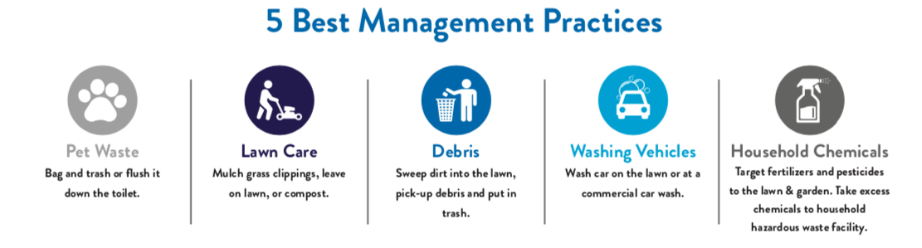
The Stormwater Coalition utilized EPA guidance for including BMP information in education, involvement and outreach efforts, as a matter of course. “Effective stormwater management often occurs by using a holistic system management approach. This approach takes into account the effectiveness of each stormwater practice, the costs of each practice, and resulting overall cost and effectiveness rather than looking at each practice in isolation. Some individual practices may not be effective alone but, in combination with others, may provide a key function in highly effective systems. Phase II MS4s are required to educate their communities on the pollution potential of common activities, and increase awareness of the direct links between land activities, rainfall-runoff, storm drains, and their local water resources. The education programs must include clear guidance on steps and specific actions to be taken to reduce stormwater pollution-potential. The benefits of public education efforts cannot be understated, especially on topics such as "nonpoint source" or "stormwater" pollution.” https://www.epa.gov/npdes/national-menu-best-management-practices-bmps-stormwater#edu

Figure 1.1- BMP messaging delivered through reusable grocery bags

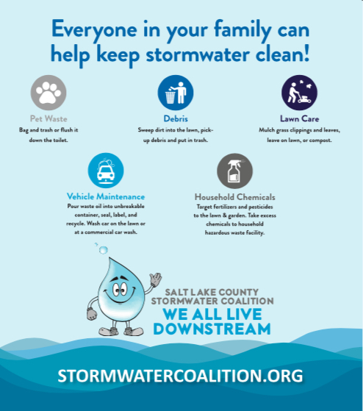

Implementation of Technical Education Program

Technical education programs for developers, planners, architects, engineers, elected officials, and community leaders, etc. on the water quality aspects of stormwater runoff and methods for improvement included utilization of the Salt Lake County Storm Water BMP guidance documents http://slco.org/engineering/stormwater/guidance-documents/, the latest information from EPA, and results of informal surveys with coalition partners about needs in their cities. The Stormwater Coalition has developed online resources for use in meetings and technical trainings, in addition to producing a 12-minute SWPPP video for Contactors. The video along with a quiz, quiz answers and a SWPPP Notice of Intent Template can be found on the Stormwater Coalition website at: https://stormwatercoalition.org/coalitionmembers
The bundle of information is designed to outline the requirements for containing runoff from construction areas, and to be used by Coalition member cities as part of the permitting process for construction sites.

Figure 2.0- Training Video Cover

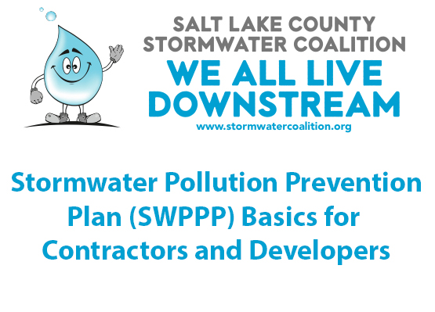

Implementation of Training Programs for Public Sector Personnel

During the reporting period, implementation of training programs for public sector personnel (municipal operations and public works departments) for the protection of stormwater quality the Coalition utilized a full service online training program for Municipal Employees designed, built and implemented by Salt Lake County, which is now merging onto the SL County SABA Learning System (https://slco.org/human-resources/employee-university/saba-lms/).

Three Stormwater related subject modules were created and are now available for training purposes: 1) Construction, 2) Illicit Discharge Detection and Elimination (IDDE), and 3) Good Housekeeping. More than 800 employees, who are required to be trained annually on these subjects, have been successfully trained and have passed a mandatory quiz for each module, so that the employee can show knowledge and retention about keeping stormwater clean while on the job.

Figure 3.0- Salt Lake County Stormwater Training System Cover

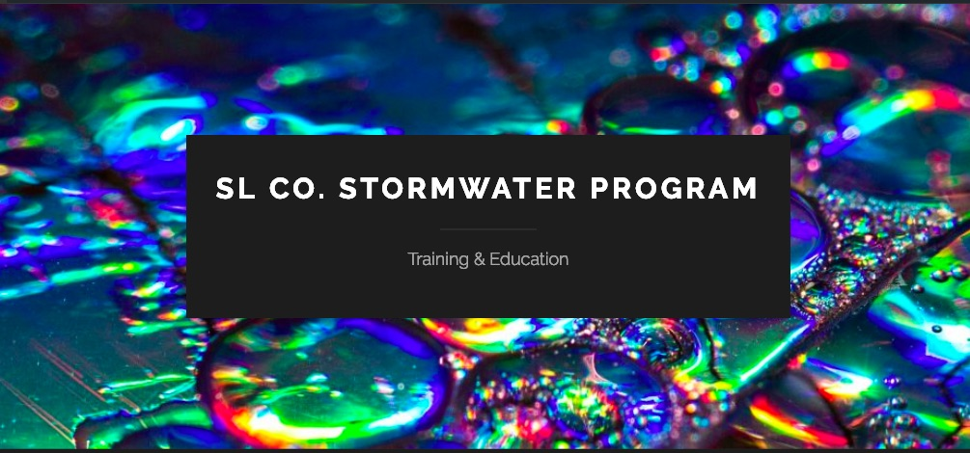

4. Educational Engagement: Salt Lake County Stormwater Coalition Water Quality Fair

Figure 4.0- 2019 SLCo Stormwater Coalition Water Quality Fair at Hogle Zoo
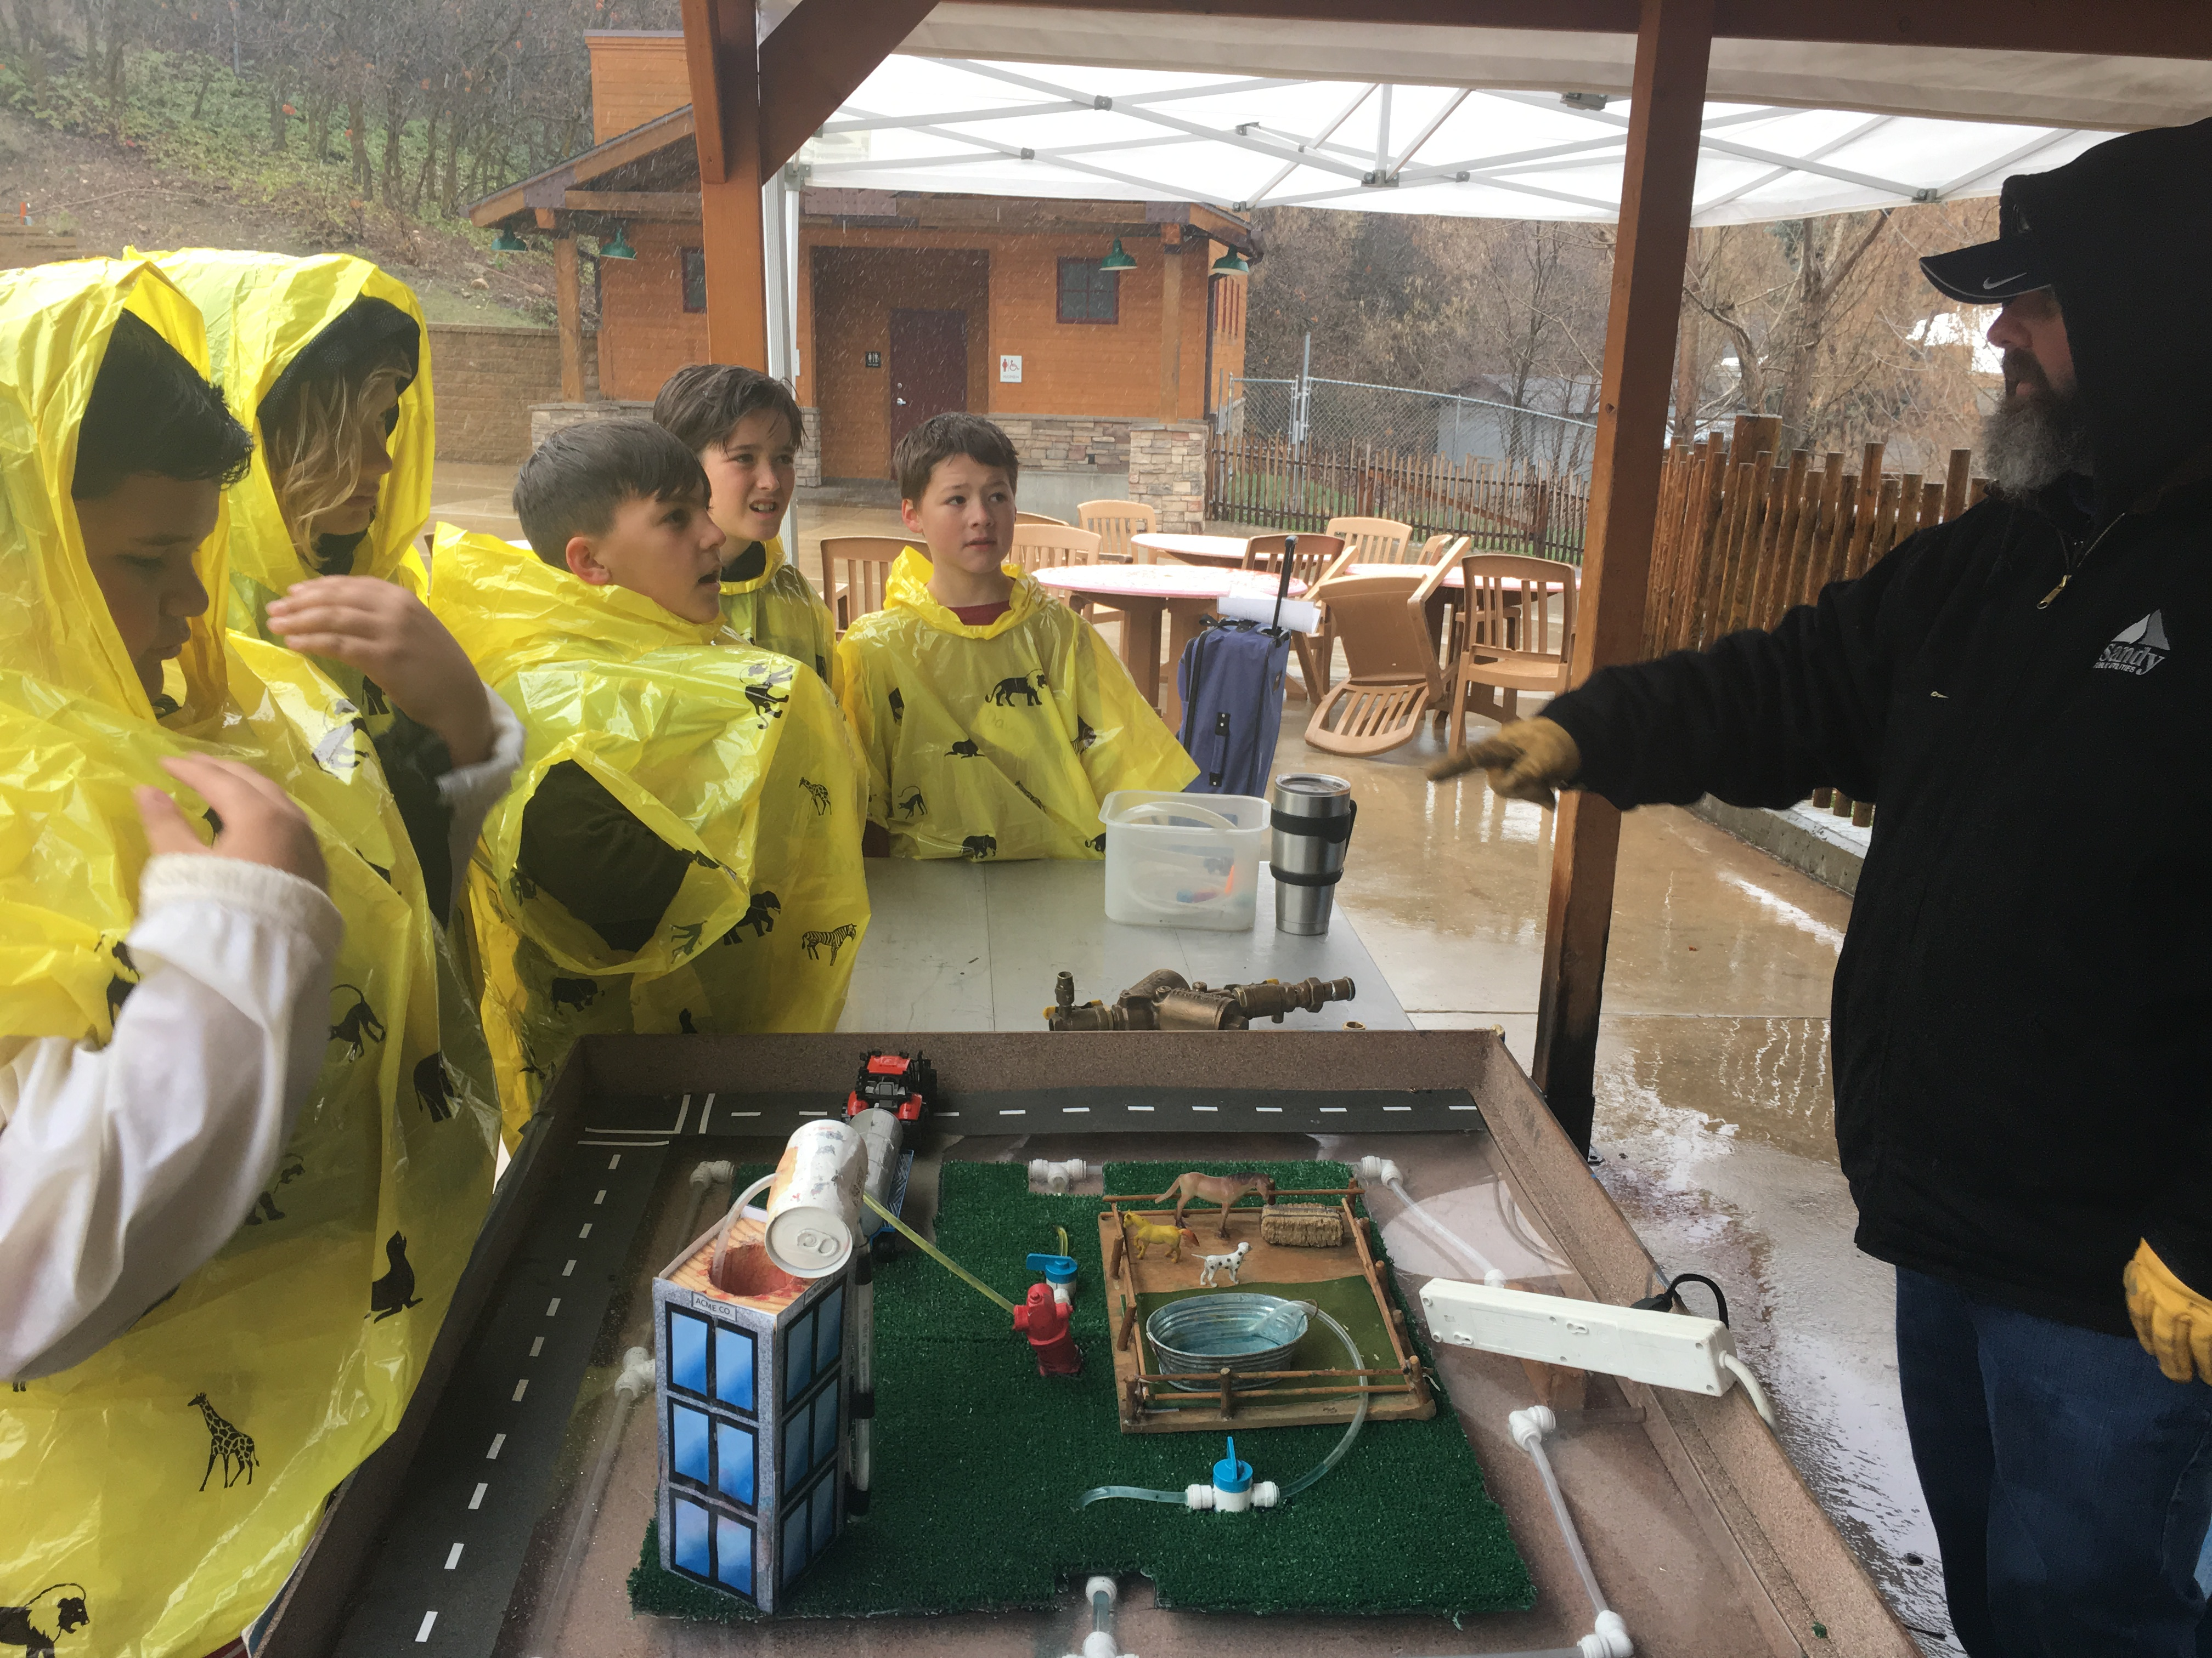
The Salt Lake County Stormwater Coalition held its 13th annual 4th Grade Water Quality Fair at Utah Hogle Zoo on April 10 and 11, 2019. The Water Quality Fair proved especially relevant to stormwater education this year, as it snowed and then rained throughout the event. The timely storms, in addition to the 13 exhibits and activities provided students with exposure, practices, activities, and insights about how to keep stormwater clean.
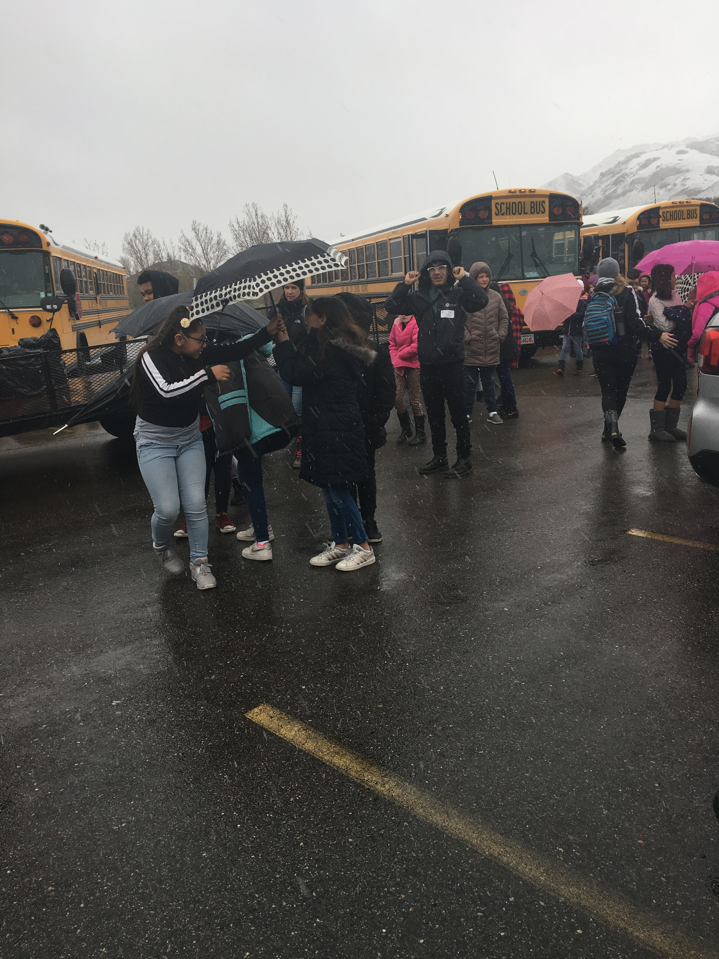
Figure 4.1- Stormwater Education Live at 13th Annual SLCo Stormwater Coalition 4th Grade Water Quality Fair
4th grade students and their teachers and parent chaperones attended from schools located in Coalition member cities (as illustrated by Figure 4.4). Students participated in hands-on activities and learned about stormwater. The message: “Whatever get into storm drains goes directly into the ponds, streams, creeks, rivers, and lakes near our homes, schools, parks and across our neighborhoods and communities. This water does not go to a water treatment facility.”

Figure 4.2- Students at the 2019 4th Grade Water Quality Fair visit the USU Hydrology Trailer to learn about pervious and impervious surfaces

